PROJECT REPORT

1 INTRODUCTION

* 1. Overview

Global air transportation refers to the complex system of moving people, goods, and cargo by air across international boundaries and within countries. This mode of transportation is an integral part of the modern world's interconnected economy and facilitates the rapid movement of people and products around the globe. Here's a detailed description of global air transportation.

* 1. Purpose

1. Passenger Travel: One of the primary purposes of global air transportation is to facilitate the movement of people across long distances, both domestically and internationally. It enables individuals to travel for business, leisure, education, medical treatment, and more. Air travel offers speed and convenience, making it a preferred mode of transportation for long-distance journeys.
2. Cargo and Freight Transport: Air transportation plays a crucial role in the global supply chain, allowing for the rapid and efficient movement of goods, including perishable items, high-value products, and time-sensitive shipments. This is especially important for international trade and e-commerce.
3. Problem definition & Design 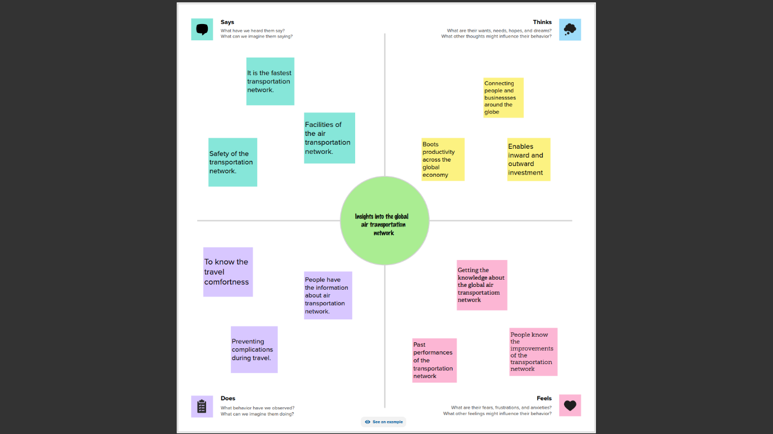

2.2 Brainstorming Map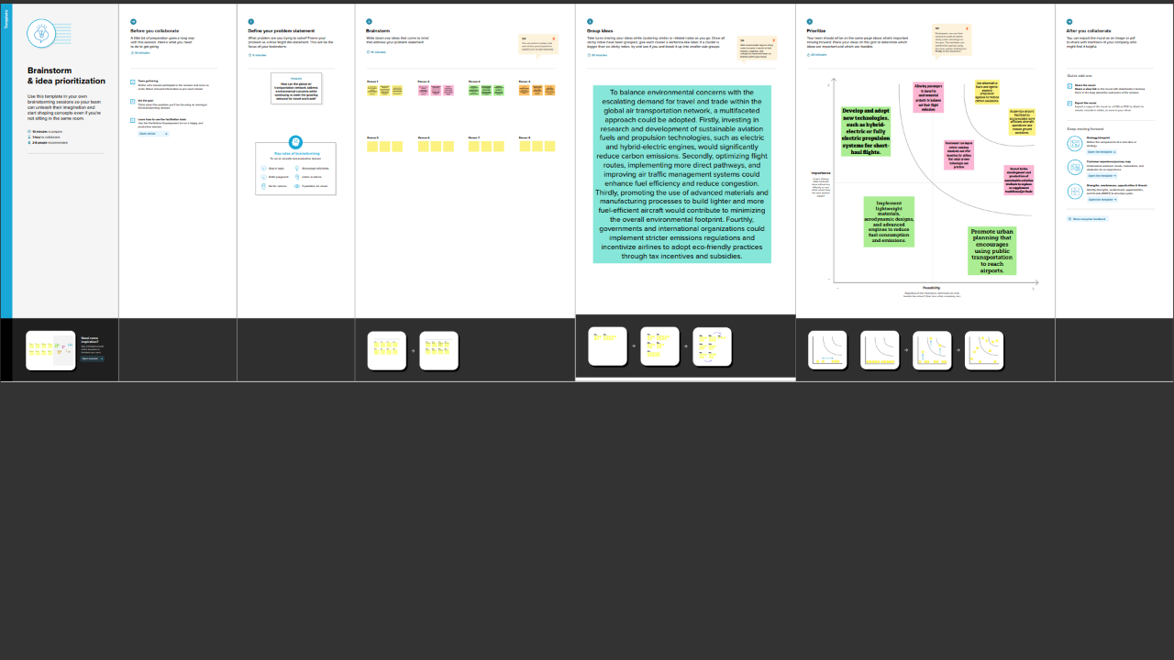

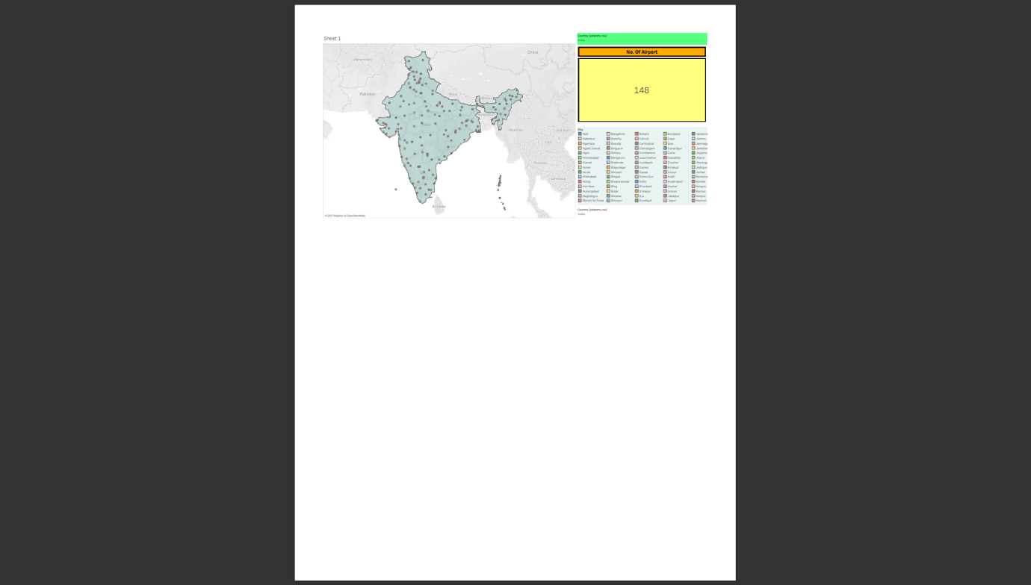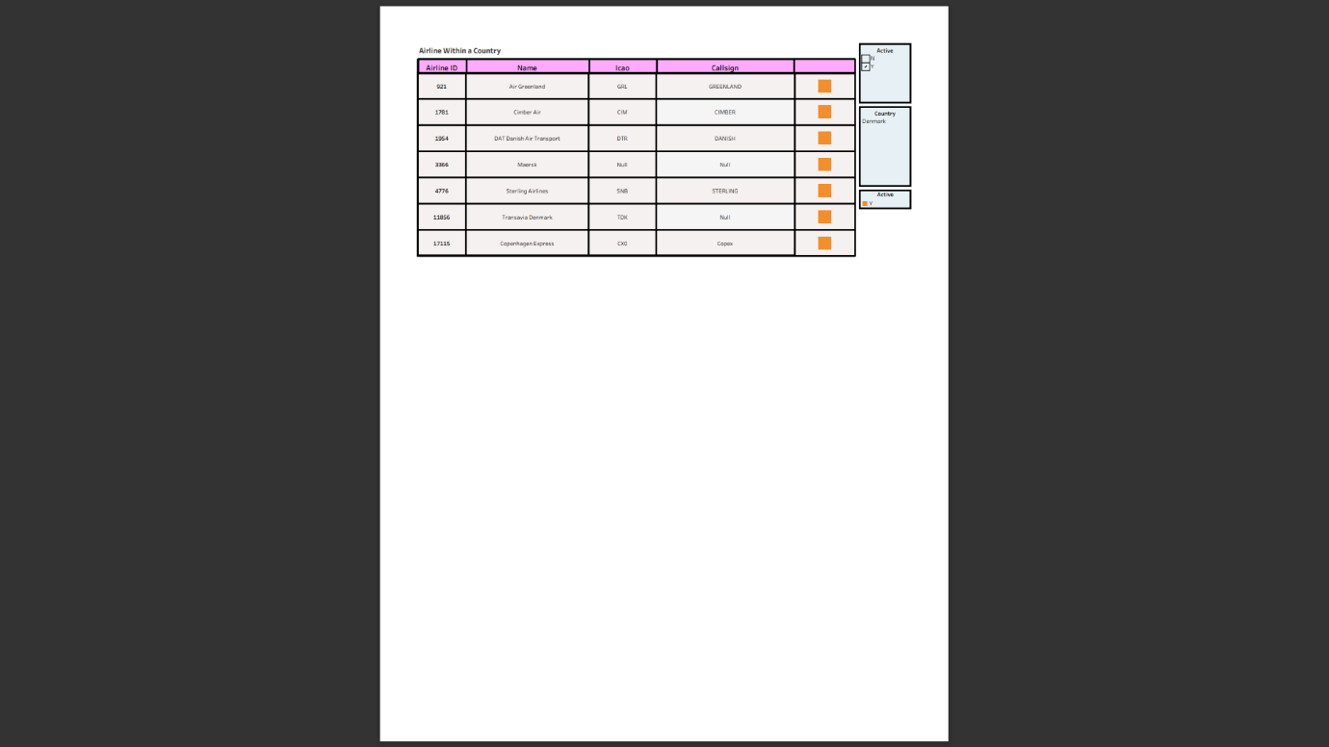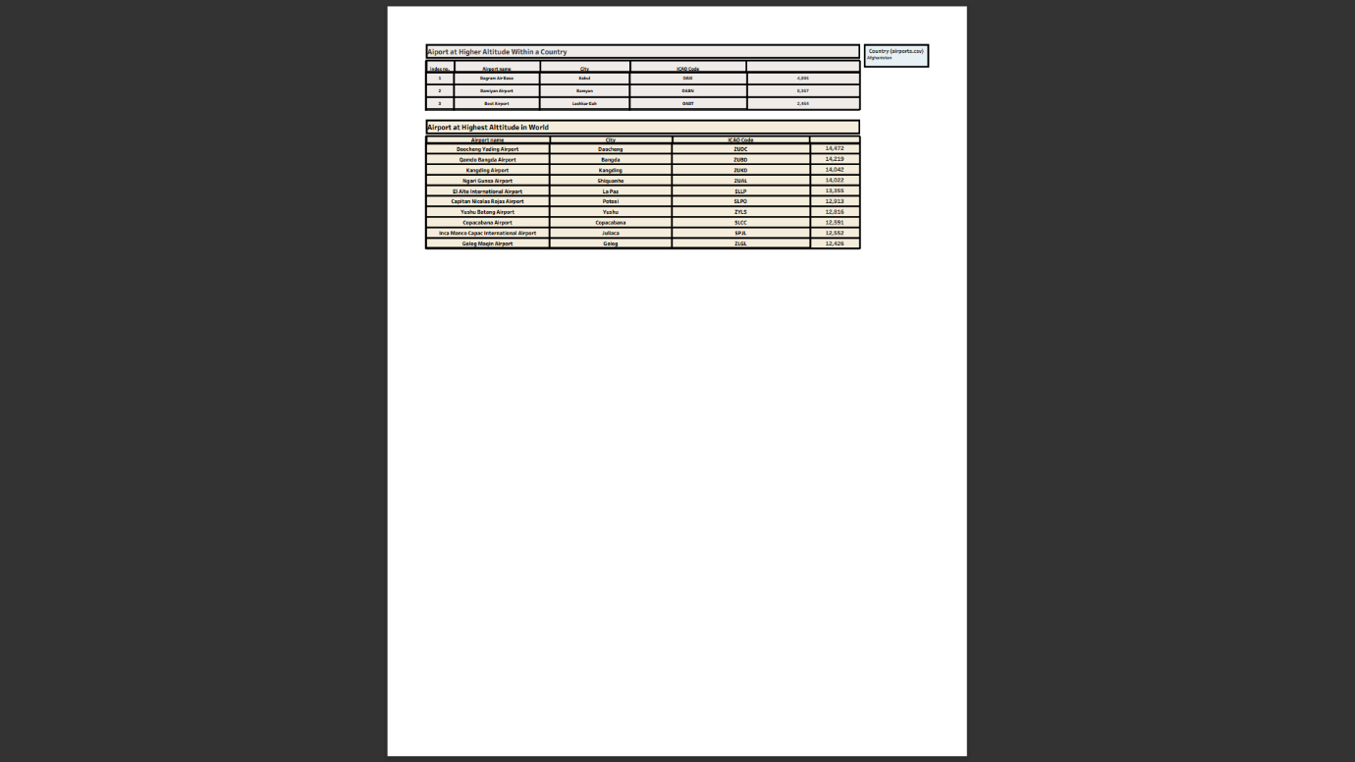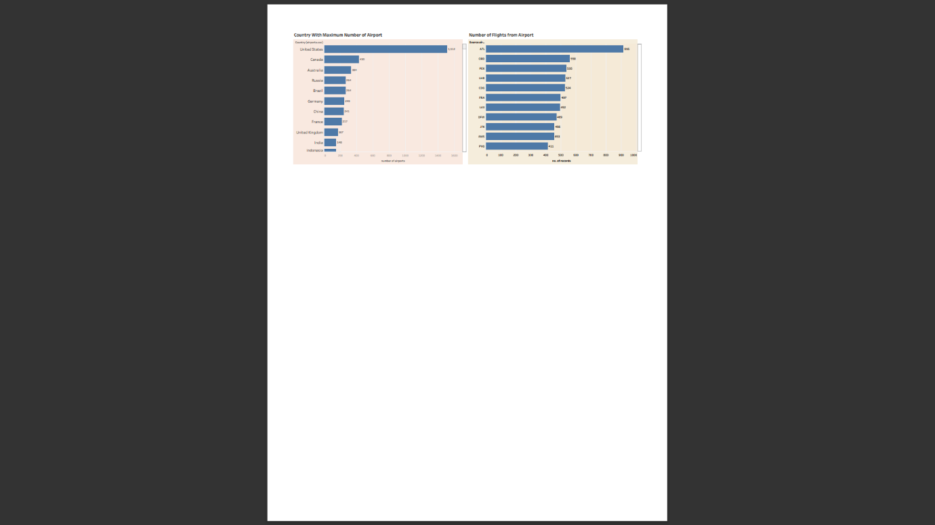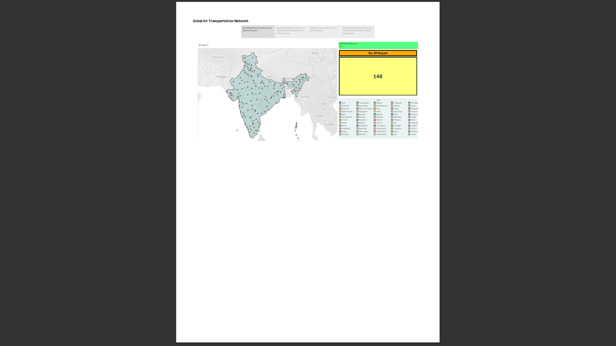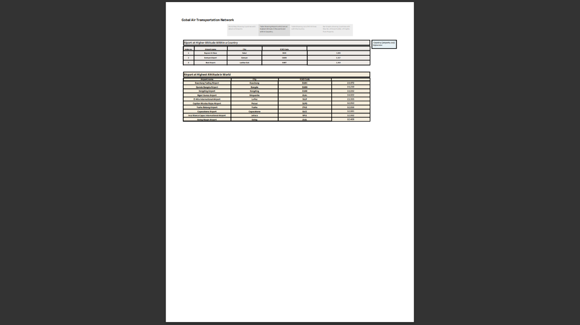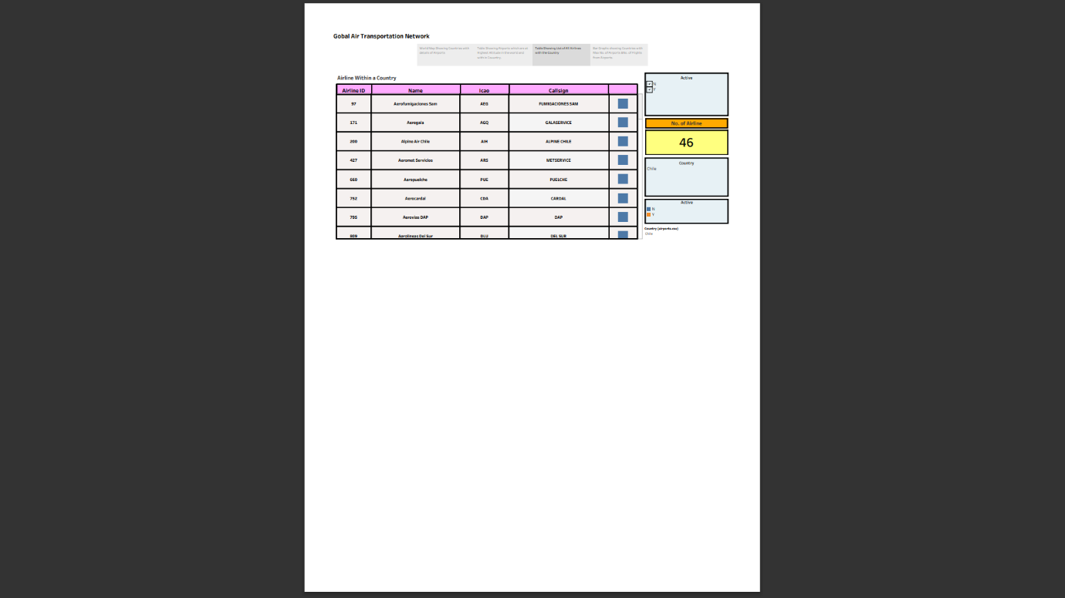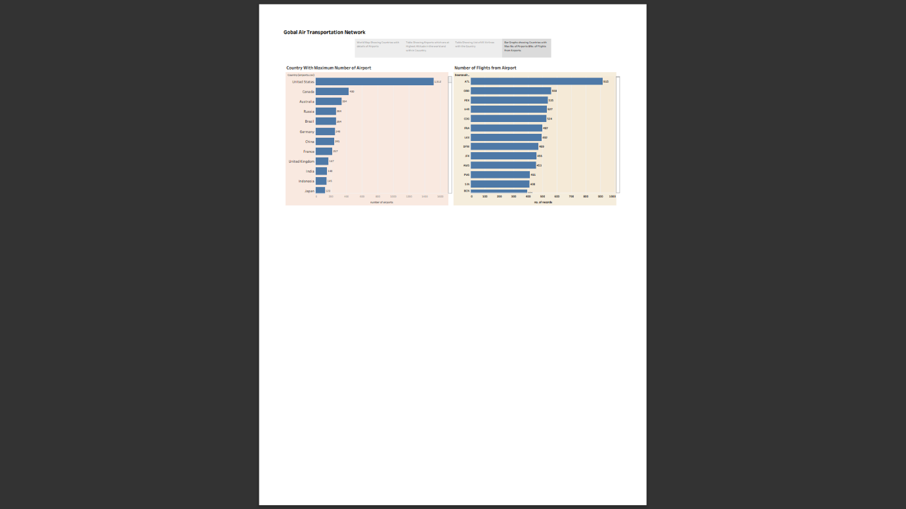

4.ADVANTAGE:

1.Speed: Air travel is one of the fastest modes of transportation available. It allows people and goods to reach their destinations quickly, making it ideal for long-distance and time-sensitive journeys.

2.Connectivity: Airports are distributed worldwide, offering extensive connectivity between cities, countries, and continents. This network allows for global trade, tourism, and communication.

DISADVANTAGE:

One of the most significant drawbacks of global air transportation is its environmental impact. Commercial aviation is a major contributor to greenhouse gas emissions, including carbon dioxide, which contributes to climate change. Additionally, aircraft emissions at high altitudes can have a more potent warming effect. Efforts to reduce the environmental impact of aviation, such as the development of more fuel-efficient aircraft and the use of sustainable aviation fuels, are ongoing but face challenges.

APPLIATION:

**User Authentication and Authorization:**

* + Implement secure user authentication for both passengers and airline staff.
  + Assign different roles and permissions to users (e.g., passengers, flight crew, airline staff, administrators).

**Flight Management:**

* + Schedule and manage flight details, including departure and arrival times, aircraft type, and routes.
  + Monitor flight status and provide real-time updates to passengers.
  + Integrate with aviation authorities for regulatory compliance

CONCLUSION:

Air transportation has greatly expanded our world's connectivity. It allows people and goods to move quickly and efficiently across vast distances, fostering economic growth, cultural exchange, and international cooperation. The aviation industry plays a crucial role in the global economy, generating jobs, stimulating trade, and supporting a wide range of associated businesses, from tourism to aerospace manufacturing.

FUTURE SCOPE:

Continued advancements in aircraft technology, including more fuel-efficient engines, composite materials, and improved aerodynamics, will lead to more environmentally friendly and cost-effective air travel. The development of supersonic and hypersonic aircraft may also revolutionize long-distance travel. The aviation industry is under increasing pressure to reduce its environmental impact. Sustainable aviation fuels (SAFs), electric and hybrid-electric aircraft, and carbon offset programs will play a significant role in reducing the carbon footprint of air travel.

Thank you